Findings Analysis

Attribute Selection
The finding attributes for certain attacks has been evaluated by using WEKA attribute evaluator , decision tree classify algorithm with cross validation 10 folds ,UNSW-NB15 dataset ,chosen BestFirst and 5 folds for evaluator method and option in order to improve accuracy when designing decision tree model and it would be discuss further.

DoS Attack
Dataset has been edited by removing other attacks class expect DoS to identify which attributes would be related and total data instances has became 41,089 from 82,332.There are 13 attributes has been selected for Denial of Service attack , which are duration,protocol,service,state,source bytes, destination bytes, sttl, destination load, sjit,response body len, ct-destination-source-ltm, is ftp login and ct-ftp-cmd. Then, selected attributes has been re evaluate and it showing the accuracy has increased from 99.12 became 99.34 percent.

Backdoor Attack
Secondly, to identify which attributes has related to backdoor attack, dataset has been edited by removing other attacks expect backdoor attack and total data instances has became 37,583 from 82,332. Found there are 4 attributes has been selected , which are protocol,sbytes,dttl and sloss. Then, re evaluate dataset , the accuracy has increased from 99.86% became 99.90%.

Exploit Attack
Next , identify which attributes has related to Exploit attack , dataset has been edited by removing other attacks expect exploit attack and total data instances has became 48,132 from 82,232. Found there are 14 attributes has been selected , which are dur,proto,service,sbytes,dbytes,sttl,dloss,sinpkt,sjit,stcpb,dmean,response_body_len,ct_src_dport_ltm and ct_dst_src_ltm. . Then, re evaluate dataset , showing accuracy has increased from 98.42 to 98.69 percent

DoS,Backdoor and Exploit
Also, we identify which attributes has related to those attacks to ensure accuracy of selected attributes from evaluate test has been conducted. Total data instances has changed from 82,332 to 52,804 and found there are 18 attributes has been selected , which are dure,service,spkts,dpkts,sbytes,dbytes,sttl,dttl,dloss,sinpkt,dwin,dmean,response_body_len,ct_state_ttl,ct_dst_src_ltm,is_ftp_login,ct_ftp_cmd, and ct_srv_dst.Then, re evaluate dataset, showing the accuracy has increased from 90,47 to 90,80 percent

Conclusion Selection Attribute
Following the result of evaluated attribute tests, then we concluded to select protocol and source bytes as attribute to design classify machine learning model. Also, we have re evaluate by using WEKA,cross-validation 10 folds and it showing the accuracy has reached 83.56 percent.

Logistic Regression
Following selected attribute discussion, then we has labelled UNSW-NB15 dataset into 2 code number which are normal traffic in dataset would be labelled as code number 1 and other type of attacks would be labelled as code number 2 , as shown in table 1.
Number Code | Description
1 | Benign
2 | DoS | Malicious
 | Backdoor
 | Exploits
Table 1 Numeratic Classification

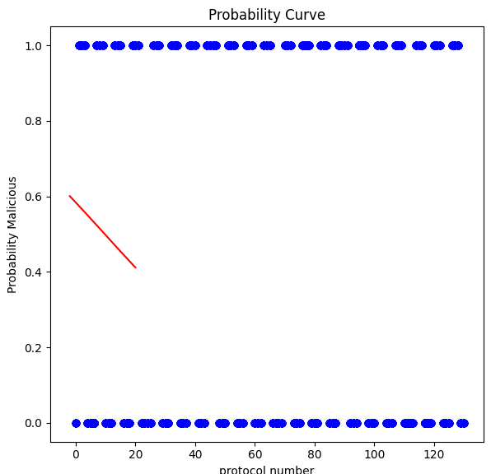
Figure 1. Protocol Logistic Regression
Figure 1 shows, the dataset has been split test by using 33 percent data size and tested logistic regression to determine which protocol has indicated as malicious and normal .Also, the model has been taken from Sklearn in Python libraries and it showing number protocol service who are below than 20 has potential 40 to 60 percent indicated as malicious.
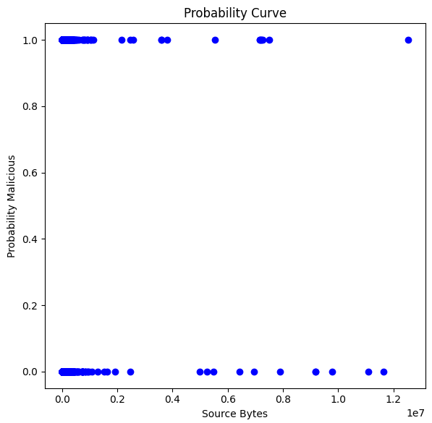
Figure 2. Source Bytes Logistic Regression
Figure 2 shows, attribute source bytes has been tested by using Sklearn logistic regression model, 33 percent data size and it showing not detected malicous network in dataset.

